

Palestine Technical University - Kadoorie

Faculty of Engineering and Technology

Computer Systems Engineering Department

**“Introduction to Graduation Project” Thesis**

**AUGMENTED REALITY EYEGLASSES STORE**

**Prepared by:**

Mahmoud Qasem

Omar Abbadi

**Supervised by:**

Nael Salman, Ph.D.

Tulkarm, Palestine

January, 2023

This document was submitted in fulfilment of the requirements for the "Introduction to

Graduation Project" course, during the academic year 2022-2023 (Fall Semester).

**ABSTRACT**

This e-commerce project is focused on the development of an online platform for selling glasses with a virtual try-on feature. The platform will use augmented reality to simulate glasses fit, it analyzes environmental data gathered by device sensors and overlays additional contextual information (in 2D or 3D) on top of that image, to create realistic virtual representations of glasses on a customer's face. This will allow customers to try on a variety of frames without having to physically visit a store, and can also help to reduce the number of returns due to poor fit. From the name our system provides a set of functionalities such as, browsing items, adding them to cart and making purchases. Overall, this e-commerce project aims to improve customer satisfaction and make the purchasing process more convenient and efficient for customers.

**TABLE OF CONTENTS**

ABSTRACT …………………………………………………………………………………. I

TABLE OF CONTENTS …………………………………………………………………… 01

**CHAPTER 1 INTRODUCTION ……………………………………………......................03**

* 1. Overview………………………………………………………………………………03
  2. Problem statement …………………………………………………………………….04

**CHAPTER 2** **LITERATURE REVIEW ……………………………………………….….06**

2.1 Similar Work …………………………………...……………………………………06

2.2 Related Work ………………………………………………………………………...06

**CHAPTER 3 OBJECTIVES …………………………………………………………….... 08**

**CHAPTER 4 METHODOLOGY ……………………………………………………….... 09**

4.1 Introduction ………………………………………………………………………….09

4.2 Approach …………………………………………………………………………….10

4.3 Process Model ……………………………………………………………………….12

4.4 Tools and Technology ……………………………………………………………….13

**CHAPTER 5** **SYSTEM REQUIREMENTS ………………………………………………15**

5.1 Functional Requirements …………………………………………………………….15

5.2 Non-Functional Requirements ……………………………………………………….18

**CHAPTER 6 DIAGRAMS ……………………………………………………………………21**

6.1 Use-case Diagram……………………………………………………………………..21

6.2 Sequence Diagram ……………………………………………………………………23

**CHAPTER 7 REFERENCES ………………………………………………………………...25**

**INTRODUCTION**

* 1. **Overview:**

E-commerce for selling glasses using virtual try-on feature is an online shopping platform that allows customers to virtually try on different glasses before making a purchase. This can be done through the use of a webcam or a smartphone camera, which captures an image of the customer's face and overlays different glasses frames on the image in real-time. This allows customers to see how different glasses look on them without having to physically try them on. This feature can be integrated into an e-commerce website or mobile app, and it can be used in conjunction with other features such as filters, recommendations, and reviews to help customers find the perfect pair of glasses.

**1.2 Problem Statement:**

  The problem that this e-commerce project aims to solve is the lack of a convenient  
and an efficient way for customers to try on glasses before making a purchase. Customers may struggle with finding the right fit, style, or color without trying it on, which can lead to dissatisfaction and an increase in returns. Additionally, many customers may not have access to physical stores or may prefer to shop online. This can make it difficult for them to try on glasses before making a purchase, leading to a suboptimal buying experience. By developing an online platform for selling glasses with a virtual try-on feature, this project aims to provide customers with a more accurate representation of how a pair of glasses will look on their faces, improve customer satisfaction and make the purchasing process more convenient and efficient.

In general, in this century, technology plays an important role in our daily activities of life. people are looking for what can save their time and effort, so, using online services that available for everybody at all time the want will achieve the goal of technology.

A lot of people nowadays need glass eye not just those who suffer from visual deficiencies, but there are glasses for protection from sunlight or computer lights, so by facilitating the process of choosing and buying glass efficiently via the internet will make life better for customers and shop owners.

**LITERATURE REVIEW**

**2.1 Similar Work:**

[**Eyeconic**](https://www.eyeconic.com/?fbclid=IwAR1-gjPUITSGkZ-3y2l7agUNiYsili82wraVl0_xdDg__07COz7U0swXB4M), [**Zenni Optical**](https://www.zennioptical.com/) is a glasses online store with a try-on feature, similar to our project, it uses a short video of the human face to generate a static video with the glasses augmented with it.

**2.2 Related Work:**

[**3dlook.me**](https://3dlook.me/)is a virtual fitting room is the digital version of an in-store dressing room that uses a virtual try-on feature, where customers can try on a product virtually to visualize how it may look on their bodies, and evaluate features such as color, pattern, and style before purchasing.

Studies have shown that customers are more likely to make a purchase if they can see how an item will fit and look on them before buying.

One study by researchers at the University of North Texas found that virtual fitting rooms can increase consumer confidence and reduce the likelihood of returns.

[**Try@Home**](https://tryathome.com/) is one such company is Warby Parker, an online retailer that offers a virtual try-on feature on their website. Customers can upload a photo of themselves and virtually "try on" different frames to see how they will look. Warby Parker uses computer vision algorithms to map the frames onto the customer's face, creating a realistic representation of how the glasses would look in real life.

Another company, Lenskart, offers a similar feature called "Try@Home." Customers can try on glasses virtually using their webcam. The try@home feature uses real-time image processing and 3D rendering technology to provide a lifelike simulation of the glasses on customer's face.

**OBJECTIVES**

1. To develop an online platform for selling eyeglasses that includes a virtual try-on feature using augmented reality (AR).
2. To allow customers to try on a variety of frames in a convenient and efficient manner, without the need to physically visit a store.
3. To provide customers with a more accurate representation of how a pair of glasses will look on their face, improving the overall shopping experience.
4. To reduce the number of returns due to poor fit by allowing customers to try on glasses virtually before making a purchase.
5. To improve customer satisfaction by providing a more convenient and efficient buying experience.
6. To increase sales and revenue for the e-commerce company by providing a more user-friendly buying experience.

**METHODOLOGY**

**4.1 Introduction**

We aim to build an e-commerce website that provides the whole set of functionalities for e-commerce, starting from browsing items to delivering items to the customer, also, this e-commerce will have a virtual try-on feature for a better shopping experience.

A virtual try-on feature will be separated into a multi-level process, such that, detecting the face borders, then detecting the critical points in the face (eyes, nose, eyebrows … etc), after that, the result should be blended with the glasses module in a correct way, such that the glasses will be in the correct form and place representing the natural and real look of eyeglasses on a human face.

In our case, since we aim to build and combine the try-on feature with an e-commerce service, not forgetting the market’s new glasses models being released frequently, the goal is to have a reliable method to enter the new glasses models into the system easily and effectively without the need to external professional tools that will be exhausting and expensive. Our blueprint is to generate such modules from photos that can be shot from our daily-use phones and cameras.

**4.2 Approach**

Since our project consists of two sub-projects, the first one is an e-commerce project, and the second is an augmented reality (AR) virtual try-on for eyeglasses, we will treat and develop each sub-project separately, and after that, they will be integrated with each other to produce the final result.

First, the e-commerce part will be divided into front-end and back-end parts, the back-end will be responsible for data storage, data retrieving, and data manipulation, and it will be separated from the front-end so that all front-end users will communicate to the same back-end layer using REST API via the HTTP protocol and its methods. The front-end part will be responsible for presenting data and being the visual interactive part that will be presented to the users in a convenient way, so the users will be aware of the front-end layer only.

Second, regarding the virtual try-on feature, after lots of research, it resulted that there is more than one approach to building this feature.

* The first one is by taking the front view of the eyeglasses, and the front view of the human face, then blending both photos together resulting in a front view of the face with the glasses on it.

* The second way is by creating a 3D model for the eyeglasses and another 3D model of the human face and blending them together to create a 3D model result, the 3D models can be generated in different ways, the easiest one is by taking multiple photos of the glasses frame and then using a 3rd party service to generate the 3D model for us, such as [Kiri Engine](https://www.kiriengine.com/) and [Qlone](https://www.qlone.pro/), and same goes for the human face.
* The third and better way is by creating a 3D model for the frame as mentioned in the previous point, and then augmenting it into a real-time view of the human face via his camera app, which is obviously an AR feature.

The preferred approach is the third one since it creates a more genuine and realistic feeling and is expected to be more preferred by users.

**4.3 Process Model**

A process model is the blueprint of the development process, it specifies how to move around with the timeline, how to respond to the outcomes correctly, and mainly how to divide the production in a way that reduces time and cost with maximum results and minimum error.

For our project, we are using the Agile model. The main benefit of this methodology is that it can append changes with ease, give some intermediate versions that can be regarded as prototypes and reduce the bugs and errors with each version release.

The methodology will be applied for the two sub-projects, since Agile is both incremental and iterative each one will have its iterations and increments. The virtual try-on part will be separated into multiple phases, such as creating a 3D model for eyeglasses, AR with face detection, and then combining all this work together, then it may take more iterations for enhancements. The mobile app part is separated into front-end and back-end as mentioned previously, they will be developed in parallel, such that the front-end will use a mock until the real API is created in the back-end.

**4.4 Tools and Technologies**

[**AR Foundation**](https://docs.unity3d.com/Packages/com.unity.xr.arfoundation@5.0/manual/index.html) Unity's AR Foundation is a cross-platform framework that allows you to write augmented reality experiences once, then build for either Android or iOS devices without making any additional changes.

The use of AR Foundation appears in augmenting the glasses frames into reality with regard to the human face.

[**Unity3D**](https://unity.com/) is a cross-platform game engine, that is used by the AR Foundation framework, and its purpose is to interact with 3D objects with regard to real-world objects which is the human head in our case.

[**Spring Boot**](https://spring.io/projects/spring-boot) is a Java-based framework dedicated to developing web applications, especially on the back-end side, its used in various architectures such as MVC and Hexagonal Architecture, and works for building both monolithic and microservices APIs.

We will use it for building our REST API that will be responsible for communicating with the database and communicating with its clients (which is the front-end side in our case) in a formal procedure using the HTTP protocol.

[**Flutter**](https://flutter.dev/)is a cross-platform framework created by Google used for developing mobile applications for both IOS and Android systems, Mac, Windows, Linux, and web applications.

We are using flutter for building a cross-platform mobile application, for our store.

**SYSTEM REQUIREMENTS**

**5.1 Functional Requirements:**

It’s important to consider the needs and goals of both the business and the users when defining functional requirements for any software application such as:

1. **Integrations with 3rd Parties**

 For selling glasses needs to integrate with a payment gateway in order to process transactions, or with a shipping carrier in order to track and deliver orders, these integrations would be considered functional requirements.

**2. Product Specification**

 It defines the specific features and capabilities that a product or system should have in order to meet the needs of its users and the business. A product specification typically includes a detailed description of the functionality that the product is expected to provide, along with any constraints or requirements that must be met in order to achieve that functionality.

For an e-commerce for selling glasses, product specification might include functional requirements such as:

* An ability for users to browse and search for glasses by various criteria, such as type, brand, price range, or color.
* An ability for users to view detailed product information for each pair of glasses, including photos, descriptions, and technical specifications.
* An ability for users to contact customer support through the app if they have any issues or questions.

Product specification can also include non-functional requirements, which are requirements that relate to the overall quality or performance of the product, rather than specific features or functionality.

1. **The Flow of Order & Checkout**

The flow of order and checkout is typically considered a functional requirement for an e-commerce application, as it defines the specific steps and processes that a user must follow in order to complete a purchase. In the case of an e-commerce for selling glasses, functional requirements related to the flow of order and checkout might include:

* An ability for users to browse and search for glasses, and to view detailed product information for each pair of glasses.
* An ability for users to add glasses to their shopping cart and proceed to checkout.
* An ability for users to enter their shipping and payment information, and to select a shipping method and payment method.
* An ability for users to track their orders and view their order history.
* An ability for the application to validate the user's input and provide feedback if any errors or issues are detected.
* An ability for the application to process the order and payment, and to confirm the order details and total cost to the user.
* An ability for the user to review and confirm their order before submitting it.

These are just a few examples of functional requirements that might be relevant for the flow of order and checkout in the project.

1. **Product visualization and customization**

Functional requirements for a virtual try-on feature might include:

* An ability for the application to detect the user's face and align the glasses with the appropriate position on the user's face.
* An ability for users to adjust the size and orientation of the glasses to get a better fit.

**5.2 Non-Functional Requirements:**

A nonfunctional requirement is an attribute that dictates how a system operates. It makes applications or software run more efficiently and illustrates the system's quality.

Knowing examples of nonfunctional requirements and how they work in an application can help us design a system that meets the needs of our end users. In this part, we define nonfunctional requirements by studying the need of this application as usability, accuracy, performance, and security and explore the best practices for designing application properties.

* **Usability:** Good software must be used easily, meaning that the flow of interactions between the user and the system should be smooth and responsive, our system will focus on this point by minimizing the number of interactions and the amount of time needed for doing some operation, also it will provide a responsive, and good-looking interface that will make the whole process easier and more reliable.
* **Accuracy:** Since our system provides glasses with virtual try-on features, such features should be accurate to match the real-life glasses experience, therefore, customers will have a better overall experience. We can say that we achieved this requirement if the result of the try-on feature is accurate at a high rate, meaning that the result has correct attributes such as normal fitting of the glasses on the human face, natural-looking, and closer to reality.
* **Performance:** In the life of the internet and mobile applications, performance is a highly required feature, which pours into usability, in general, performance must be maximized as possible, and guarantee a stable level at all times. The goal is to have our system be responsive on demand and not lazy and heavy, this will be measured relative to the current common apps and web services, such that our system will not be recognized as a slow system compared to the other systems at the current time.
* **Security:** In a system that deals with sensitive data and money transactions such as e-commerce, security is a must to have, so that users have confidence in our system. This will be achieved with some tools and technics such as JWT (JSON Web Token) which represents the ID of the HTTP request coming to the server and based on this ID the request will be identified and logged in or not. Also, we will establish a set of authorities that each user will have a number of them based on his role, so he will do what he is allowed to and will be forbidden from doing operations other than that.

**DIAGRAMS**

**6.1 Use-case Diagrams:**

**Administrator use case**

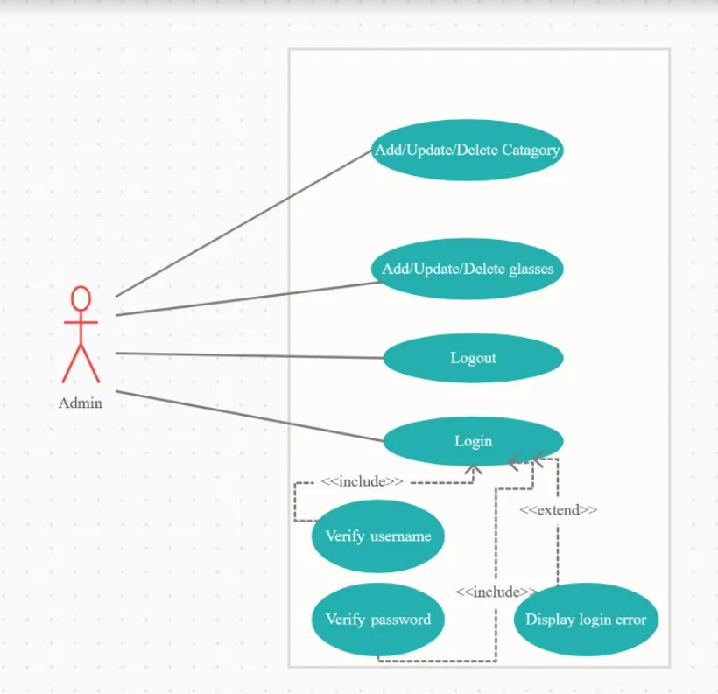

figure 1.1: Administrator use case

The use-case diagram in figure 1.1, captures the goals of the user administrator. Admin can add, delete, update category likewise sun glasses, medical glasses and can add, delete, update glasses.

**Customer use case**

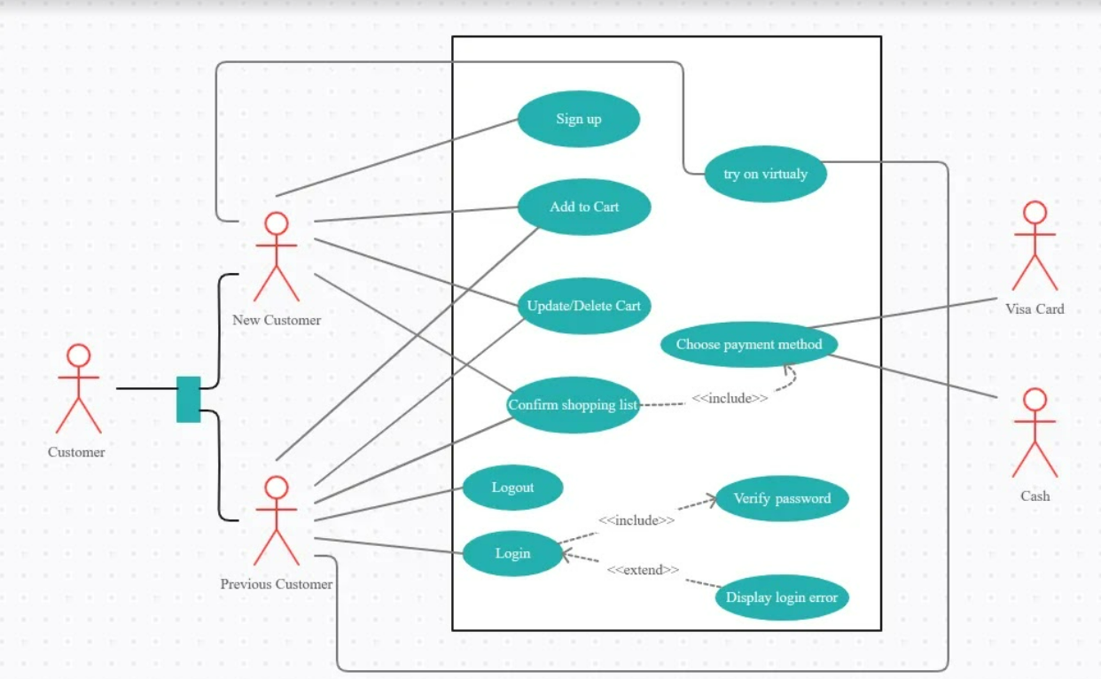

Figure 1.2: Customer use case

The customer use case diagram in figure 1.2 show the goals of customer whether was a new customer or previous customer.

New customer can sign up and fill his information and can add glasses to the cart, also can update, delete from the cart and choose payment methods.

Previous customer can login/logout and can add glasses to the cart, also can update, delete from the cart and choose payment methods.

**6.2 Sequence Diagrams:**

**Login Diagram**

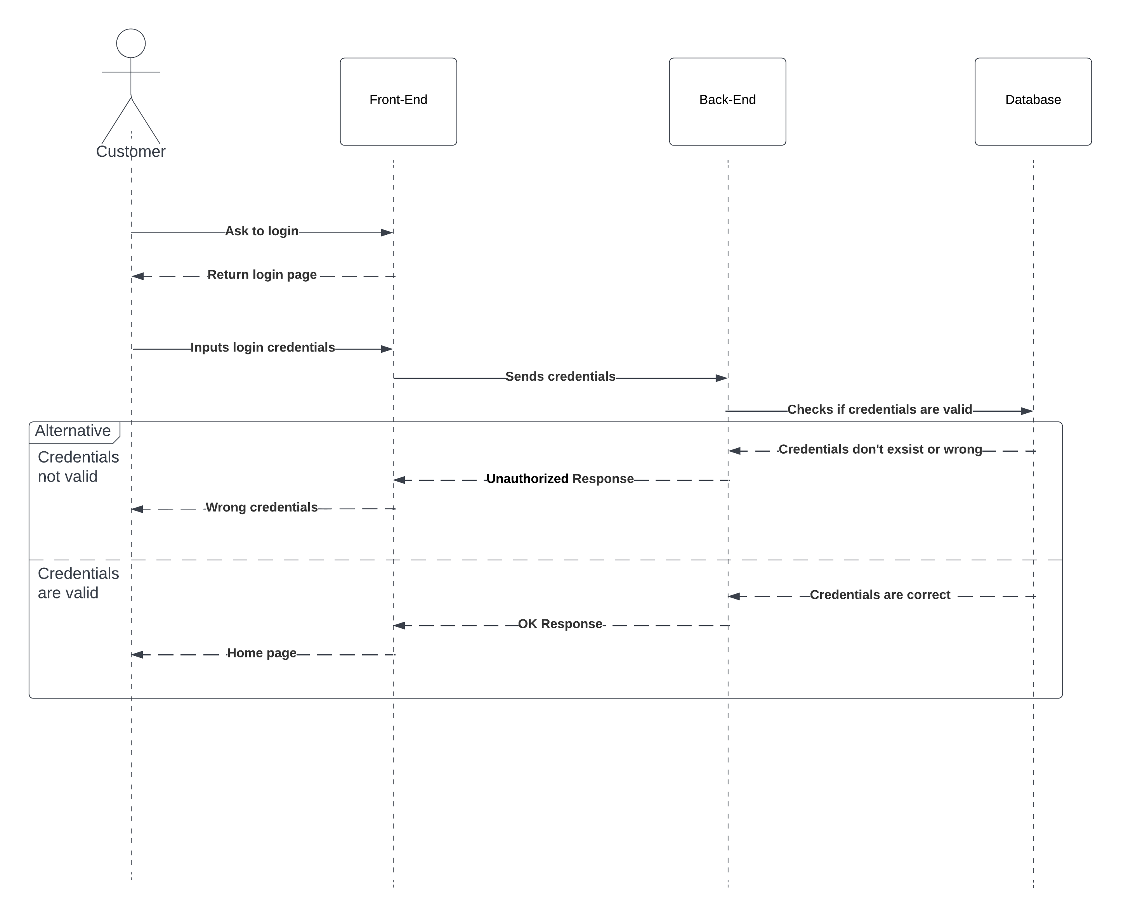

Figure 2.1: Login diagram

The following diagram shows the flow of logging into the system, it first starts by sending the login credentials of the user in a request to the backend side, then the backend checks if a user with these credentials exists or not, if so, it returns an OK response with the generated token, if not, it returns an unauthorized response.

**Payment Diagram**

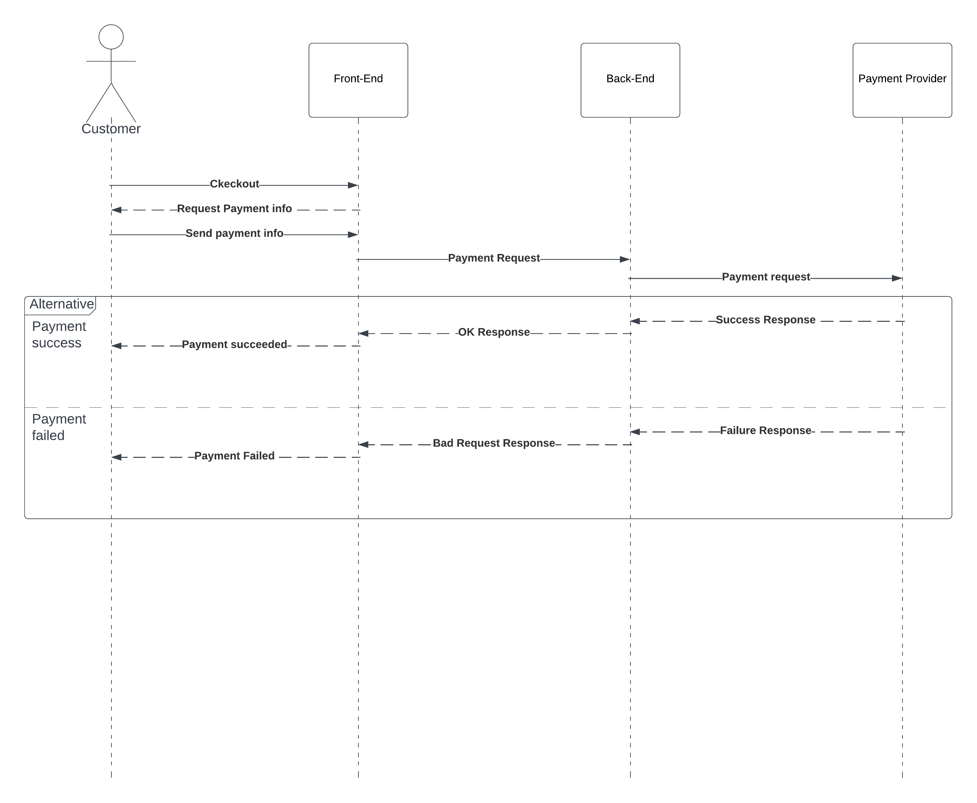

**Figure 2.2: Payment Diagram**

This diagram shows the payment process, the user asks for payment, and he gets the payment page in which he will enter the payment information such as the payment method (Visa, PayPal … etc) and the needed fields, then he sends a request with these credentials to the server, the server on his turn sends them to the correct 3rd party service for payment, and gets a response that specifies if the payment succeeded or not.

**REFERENCES**

* 1. [What is Augmented Reality (AR)? (techtarget.com)](https://www.techtarget.com/whatis/definition/augmented-reality-AR)
  2. [arcore_flutter_plugin | Flutter Package (pub.dev)](https://pub.dev/packages/arcore_flutter_plugin)
  3. [Software Requirements (tutorialspoint.com)](https://www.tutorialspoint.com/software_engineering/software_requirements.htm)
  4. [Draw Use Case Diagrams Online with Use Case Diagram Tool | Creately](https://creately.com/diagram-type/use-case/)
  5. [What is Sequence Diagram? (visual-paradigm.com)](https://www.visual-paradigm.com/guide/uml-unified-modeling-language/what-is-sequence-diagram/)